LFC Shipping and Handling Guide

Pre-Shipping And Handling actions:

To go through the Shipping and Handling process, certain requirements are necessary.

* Lost Report and Found Item are confirmed to be a match
* Lost Report has an email
* Customer is notified via Email that their item was found

This will send the customer a notification including a link to the shipping login page.

**Shipping Login Page:**

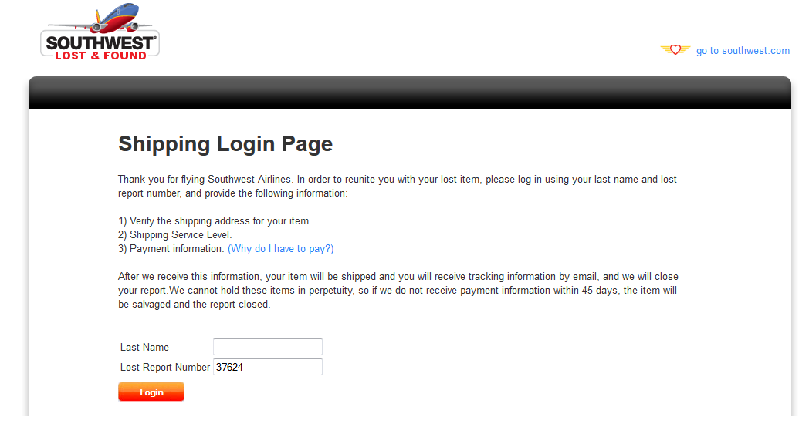

For the Shipping Login page, you’ll have two fields, Lost Report Number, which should be automatically filled when clicked from the email, and the Last Name. Both fields are necessary to login. If a user goes to this page and tries accessing their lost form before being notified by email, they shouldn’t be able to login due to the proper information not yet being created.

Once the proper last name and corresponding Lost Report Number is provided, the user will be brought to the Shipping Address Verification page.

**Shipping Address Verification Page:**

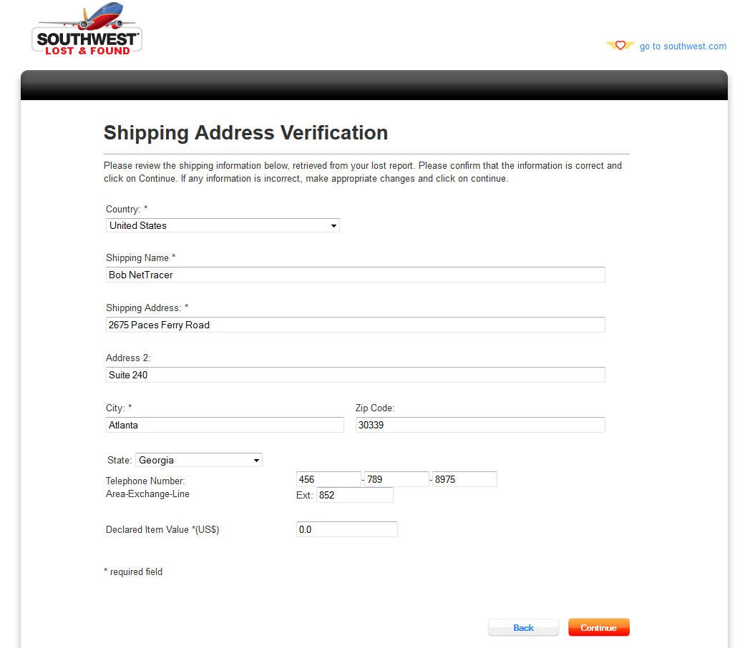

On this page, the view will pull the address information from the Lost Report, where the user can confirm the information is correct for shipping before submitting it to Fedex for validation. Notable fields detailed below:

* Country
  + This field will drive the display of certain functionalities. If the country is United States, the state field should be visible. If the country is not United States, the province field and the country section of the telephone number should be visible.
* Shipping Name
  + The name of the recipient to receive the item.
* Declared Item Value
  + Required field that the user puts it to determine the level of care Fedex will put into shipping the item.

Once the address is verified, the user will click the continue button to submit the information to Fedex. Depending on the address, it will either

1. Return a proposed address that is more accurate to Fedex’s Database
2. Accept the address as 100% accurate and proceed to process rates based on the address.
3. Decline the address due to inaccuracy or the webservice currently being unavailable.
4. Report that there are no viable rate services based on the address.

In the case of A, the user will be allowed to either select the proposed address or send their currently filled address.

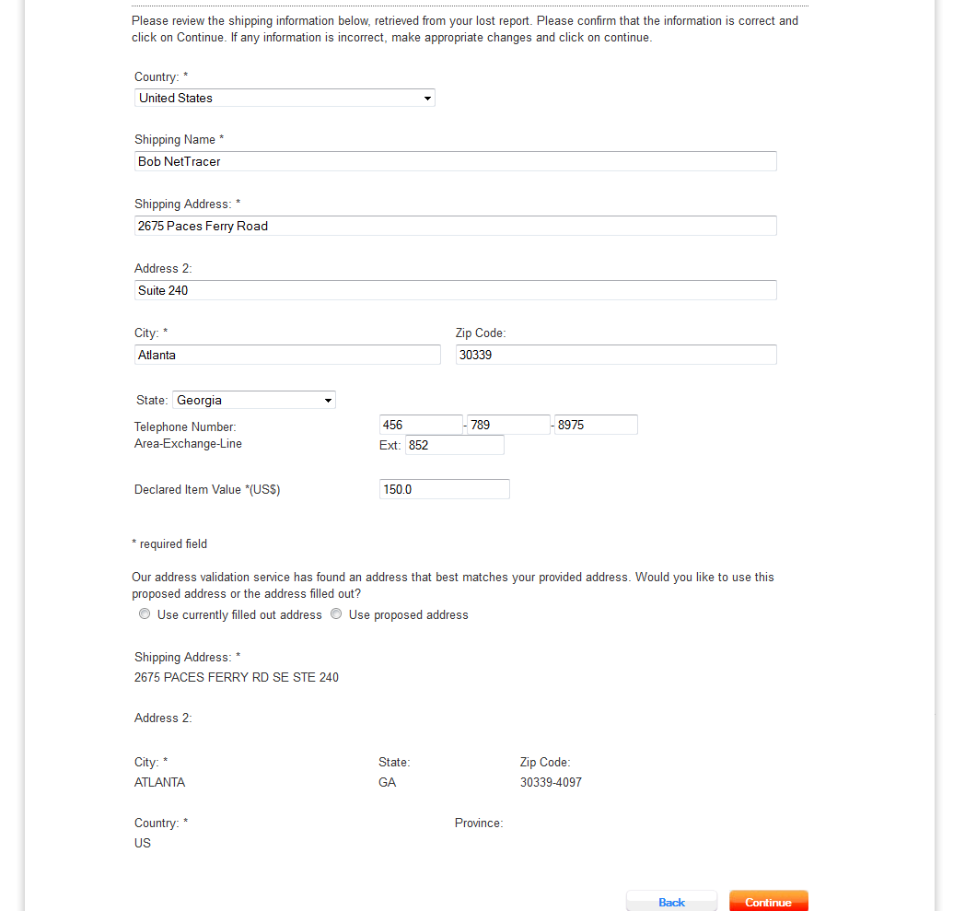

Once choosing which address, the user clicks continue and the address is processed for to select a rate.

**Shipping Rates Page:**

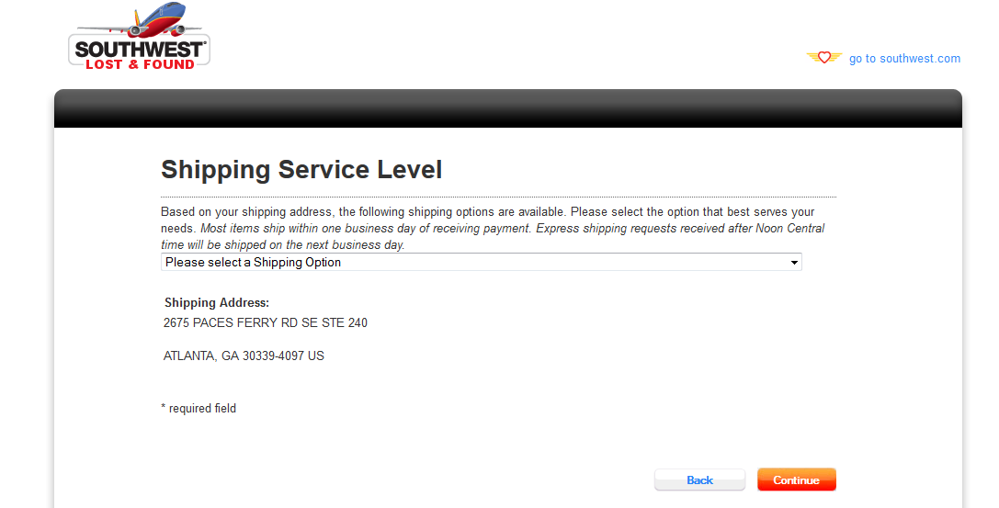

On this page, the user must select a rate before continuing. Once the user selects the rate and clicks continue, they’ll be brought to the shipping payment page.

**Shipping Payment Page:**

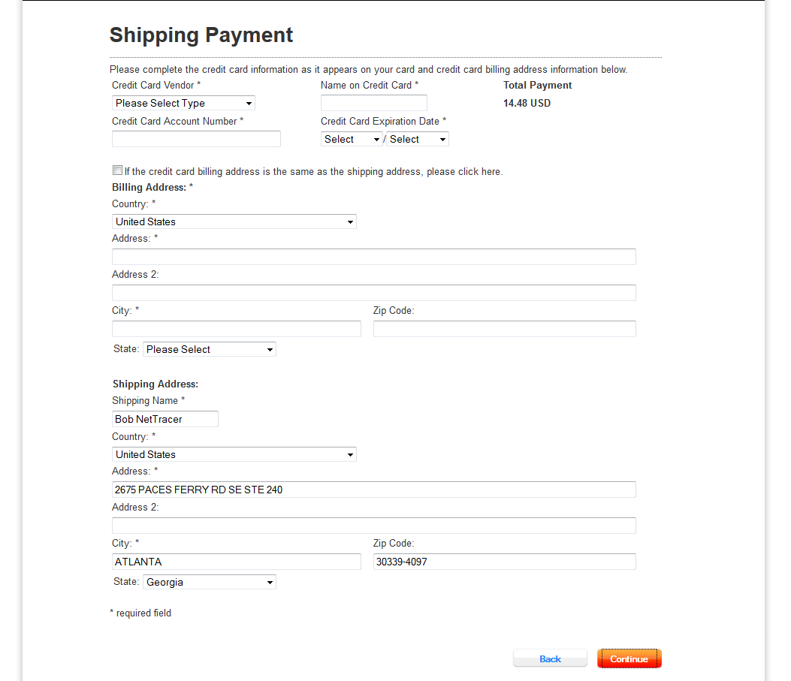

On this page, the users will fill all the billing information required to submit a payment, including the Billing Address, and Credit Card information. The Billing address can be matched to the shipping address and if this happens, then the billing address fields will be disabled. Like the shipping address verification page, the country field will command the visibility of the state and province fields. Once all the appropriate fields are filled out and the user clicks continue, the credit card information will be validated against and if the information passes validation, the user will be brought to the confirmation page.

**Shipment Confirmation:**

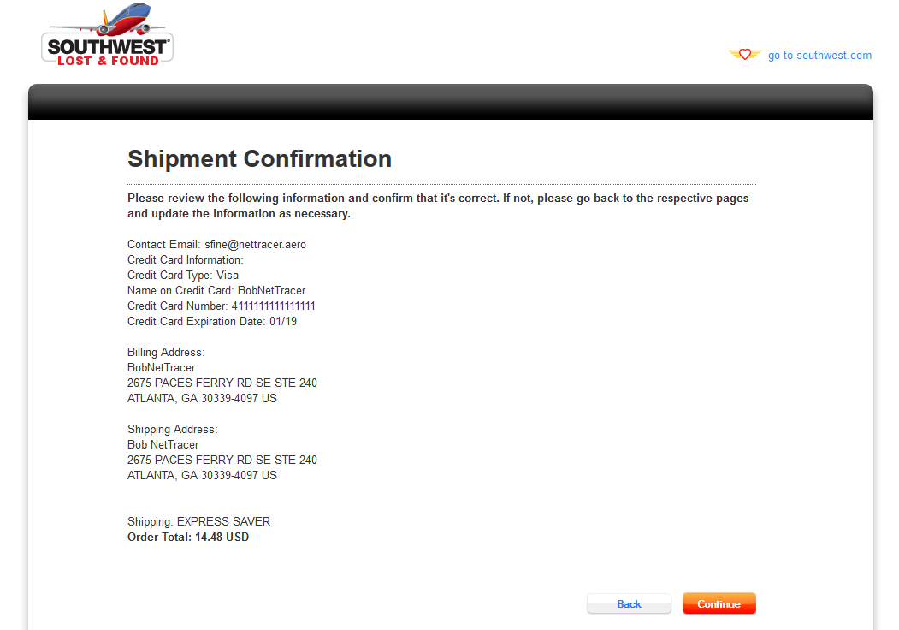

Here, the user can go over all their information, including the shipping address, billing information, and the selected shipping rate and its associated cost. Once confirmation all the information is correct, the user can click continue and process the payment and will be brought to the shipment payment received page.

**Shipment Payment Received:**

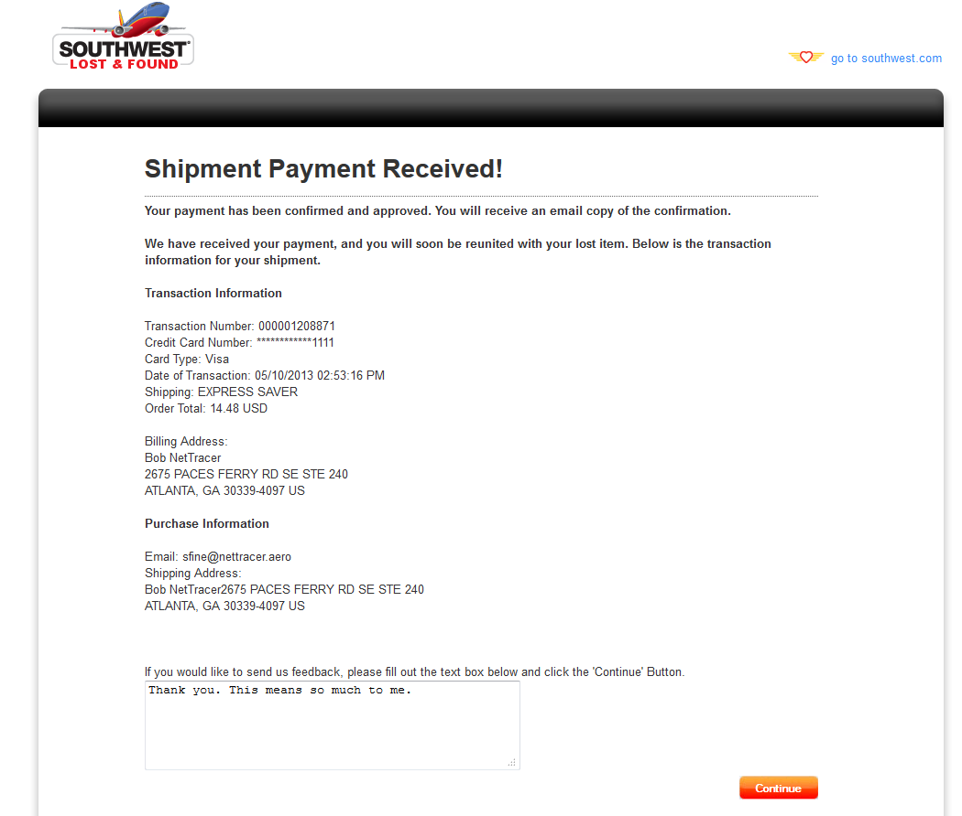

This page is the receipt information for the user to print if they desire, though they’ll be emailed a copy of this same information. Additionally on this page, the user can provide feedback for the service (which will be visible on the Lost Report itself and the Items Ready for Shipping task manager list).